ROYAL OAK INTERNATIONAL SCHOOL
SR. SEC CBSE AFFILIATED
WORKSHEET (SESSION 2019-20)
SUBJECT: E.V.S

Name: __________ Class:II/Sec: ______

Q-1 Write function of the given parts:

- Eyes: __________________________________________________
- Nose: __________________________________________________
- Ears : __________________________________________________
Q-2 Paste the picture of your family and fill the blanks:

1. There are ____________ members in my family.
2. My family is _________ (big/small)
3. My father’s name is _____________________
4. My mother’s name is ____________________
5. My sister’s/ brother’s name is ________________
6. My grandparents ____________ (live/ do not live) with us.

Q-3 Solve the following riddles:
1. 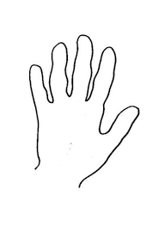 I rhyme with the word land . I am your

2. 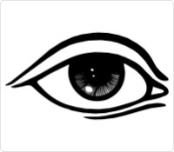 We rhyme with the word prize. We are your
3. I rhyme with the word rose . I am your

Q-4 Use the clues to unscramble the words in brackets and find the word in the maze:
1. The food we eat goes here. ( m a c h o t s )
2. This tells the body what to do. ( a i n r b )
3. The heart and lungs are inside this. ( t s c h e )
4. We breathe through our ( s n o e )
5. We taste through our ( u e g o t n )

S | T | O | M | A | C | H
J | T | D | F | R | H | O
N | O | S | E | G | E | I
B | R | A | I | N | S | A
K | V | F | O | W | T | T
T | O | N | G | U | E | D

Q-5 Name the type of family: (,Single-parent, Nuclear family, Big family, Joint family)

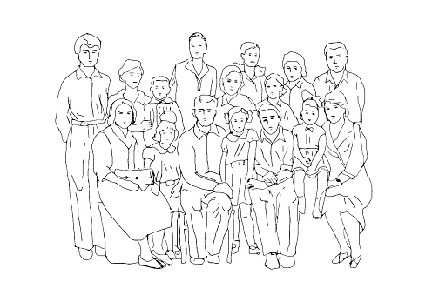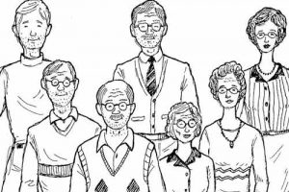
1. 2.

3. 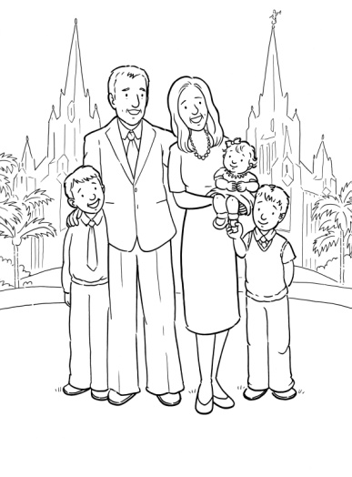 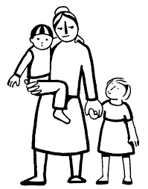
4.

Q-6 Draw and color five sense organs and label them:

